 | Course Name: Design Patterns/Thinking LAB | EXPERIMENT NO. 7
 | Course Code: 20CP210P  Faculty: Dr. Payal Chaudhari | Branch: CSE | Semester: IV
(To be filled by Student)
Submitted by: Meet Jain
Roll no: 23BCP093

Objective: To familiarize students with standard Structural design patterns.
Experiment: Explain the Facade design pattern and write a program using any object-oriented programming language to demonstrate the working of Facade design pattern.

Code:
class CoffeeMachine {
void brewCoffee() {
System.out.println("Brewing coffee...");
}
}

class MilkFrother {
void frothMilk() {
System.out.println("Frothing milk...");
}
}

class PaymentProcessor {
void processPayment() {
System.out.println("Processing payment...");
}
}

class CafeFacade {
CoffeeMachine coffeeMachine;
MilkFrother milkFrother;
PaymentProcessor paymentProcessor;

public CafeFacade() {
this.coffeeMachine = new CoffeeMachine();
this.milkFrother = new MilkFrother();
this.paymentProcessor = new PaymentProcessor();
}

public void orderLatte() {
System.out.println("Ordering a Latte...");
paymentProcessor.processPayment();
coffeeMachine.brewCoffee();
milkFrother.frothMilk();
System.out.println("Latte is ready!");
}

public void orderEspresso() {
System.out.println("Ordering an Espresso...");
paymentProcessor.processPayment();
coffeeMachine.brewCoffee();
System.out.println("Espresso is ready!");
}
}

public class FacadePatternCafe {
public static void main(String[] args) {
CafeFacade cafe = new CafeFacade();

cafe.orderLatte();
System.out.println();
cafe.orderEspresso();
}
}

Output:
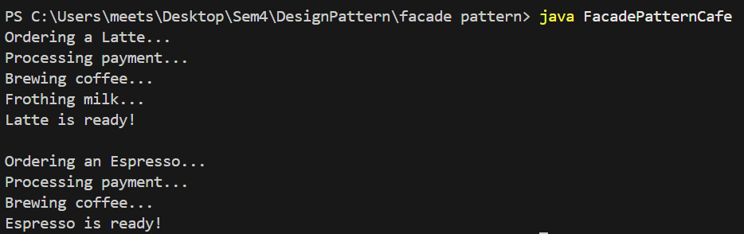

Class Diagram:

